Order Of Service

Singing: Psalm 119b—CW page 110

Reading: Psalm 106:19-39

Opening Hymn: TLH 648

Reading: Hebrews 4:1-16

Request Hymn: CW Supplement 774

Reading: Luke 7:18-23

Sermon Hymn: TLH 656

Sermon Text: Acts 7:54-60

Stephen Fell Asleep

Prayer

The Apostles’ Creed, TLH page 12

Holy Communion

The Lord's Prayer

The Blessing

Closing Hymn: TLH 577

************

Bible Study: Lambs: Octopus
Sheep: Deut. 13:1-11
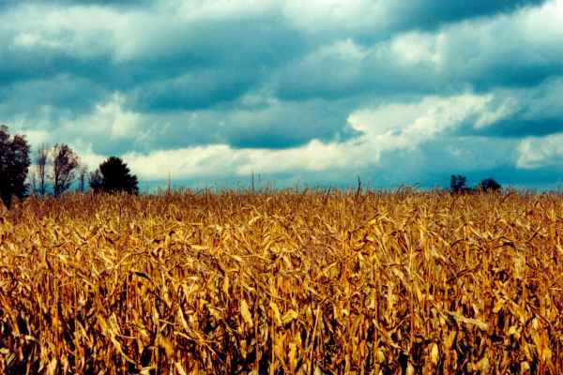

Seedtime And Harvest

Water
Of
Life

8 September 2024

W A T E R O F L I F E

Independent Christian Church—Conservative Lutheran Doctrine

Worship Service: 9:30 a.m.

Larry Cooper, Pastor E-Mail address:
lcooper@wateroflife.cc
Web Site:
www.wateroflife.cc

* * * * * * * * * * * * * * * * * * * * * * * * * * *

Sermon Text: Acts 7:54-60

Stephen Fell Asleep

* * * * * * * * * * * * * * * * * * * * * * * * * * *

54 When they heard these things, they were cut to the heart, and they gnashed on him with their teeth.
55 But he, being full of the Holy Ghost, looked up stedfastly into heaven, and saw the glory of God, and Jesus standing on the right hand of God,
56 And said, Behold, I see the heavens opened, and the Son of man standing on the right hand of God.
57 Then they cried out with a loud voice, and stopped their ears, and ran upon him with one accord,
58 And cast him out of the city, and stoned him: and the witnesses laid down their clothes at a young man's feet, whose name was Saul.
59 And they stoned Stephen, calling upon God, and saying, Lord Jesus, receive my spirit.
60 And he kneeled down, and cried with a loud voice, Lord, lay not this sin to their charge. And when he had said this, he fell asleep.

